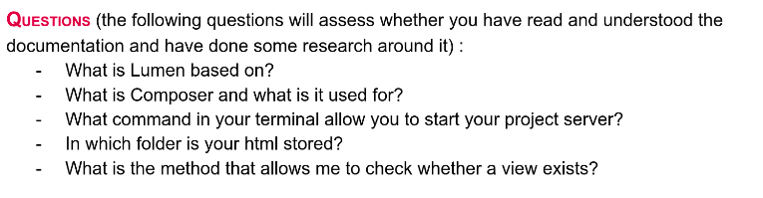
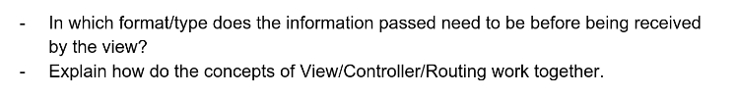

- Lumen is based on Laravel which itself baed on Symfony. It’s ligt height version og the pap framework

- Composer is a tool for dependency management in PHP. It allows me to declare the libraries my project depends on and it will manage (install/update) them.

- To start my poroject , i need to type php -S localhost:8000 -t blog/public in my terminal

- My html is stored in the folder « public »

- The method is :

$view = "Welcome";
if(view()->exists($view)){
return view('Welcome', ['name' => $name]);
}
or :

if (View::exists($view)) {
return view('Welcome', ['name' => $name]);
}
N.B : Don’t forget to add : use Illuminate\Support\Facades\View;
at the begining of the controller,

- The information passed to the view is contained by the second argument (cf
highlighted in yellow above). The second argument is an array of data. In this case, we are passing the $name variable, which is displayed in the view using echo $name. You can also use a Template engines as Blade or Twig. Informations will be displayed in the view using special syntax. Exemple : {{ name }}

- The view can be any output representation of all information (it contains the HTML) that will be displayed. This informations is sent by the controller. The controller is like a crossroad between the model and the view. It accepts input and converts it to commands for the model or view. You need also a routing system which can defined for each method controller an URL (and provide an access to the view for any user who types it in his browser).

